5.1 UI WIREFRAME: LAB WORKLIST & RESULT ENTRY SCREEN – THI
- Laboratory Worklist Screen (FR25)
The Laboratory Worklist screen provides laboratory technicians with a centralized list of all assigned specimens awaiting processing. Users can filter worklists by department, priority, specimen status, and collection date to quickly locate required tests. This interface helps staff organise daily workloads and efficiently manage laboratory operations.

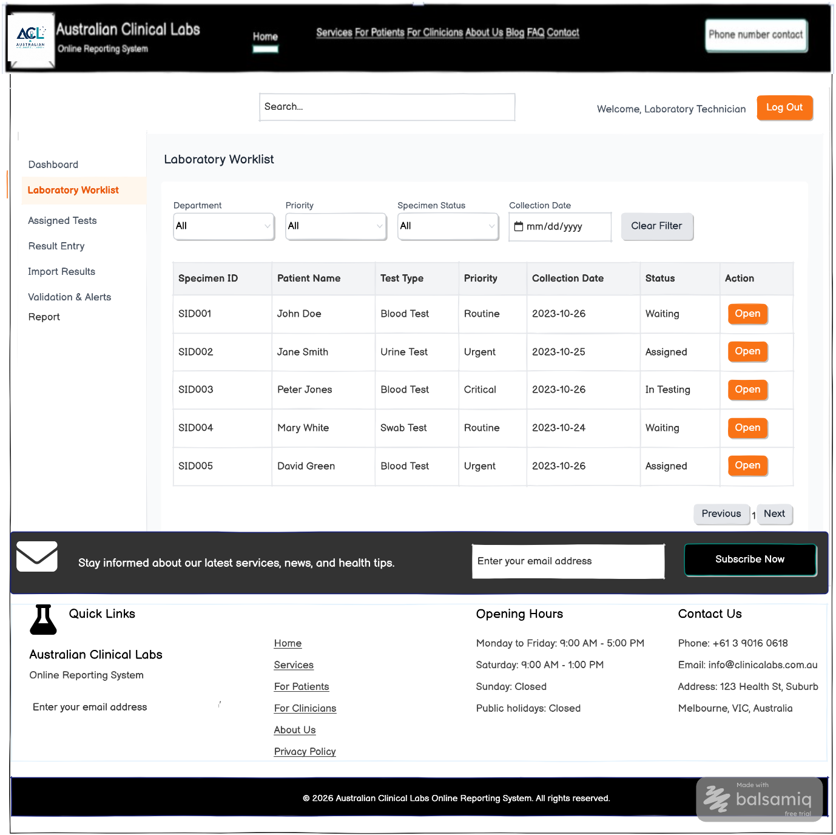
2. Result Entry Screen (FR27)
The Result Entry screen enables authorised laboratory staff to enter laboratory test results for individual specimens. Users can record numerical values, observations, measurement units, laboratory methods, and additional comments before saving or submitting the results for validation. The interface is designed to support accurate and consistent data entry.

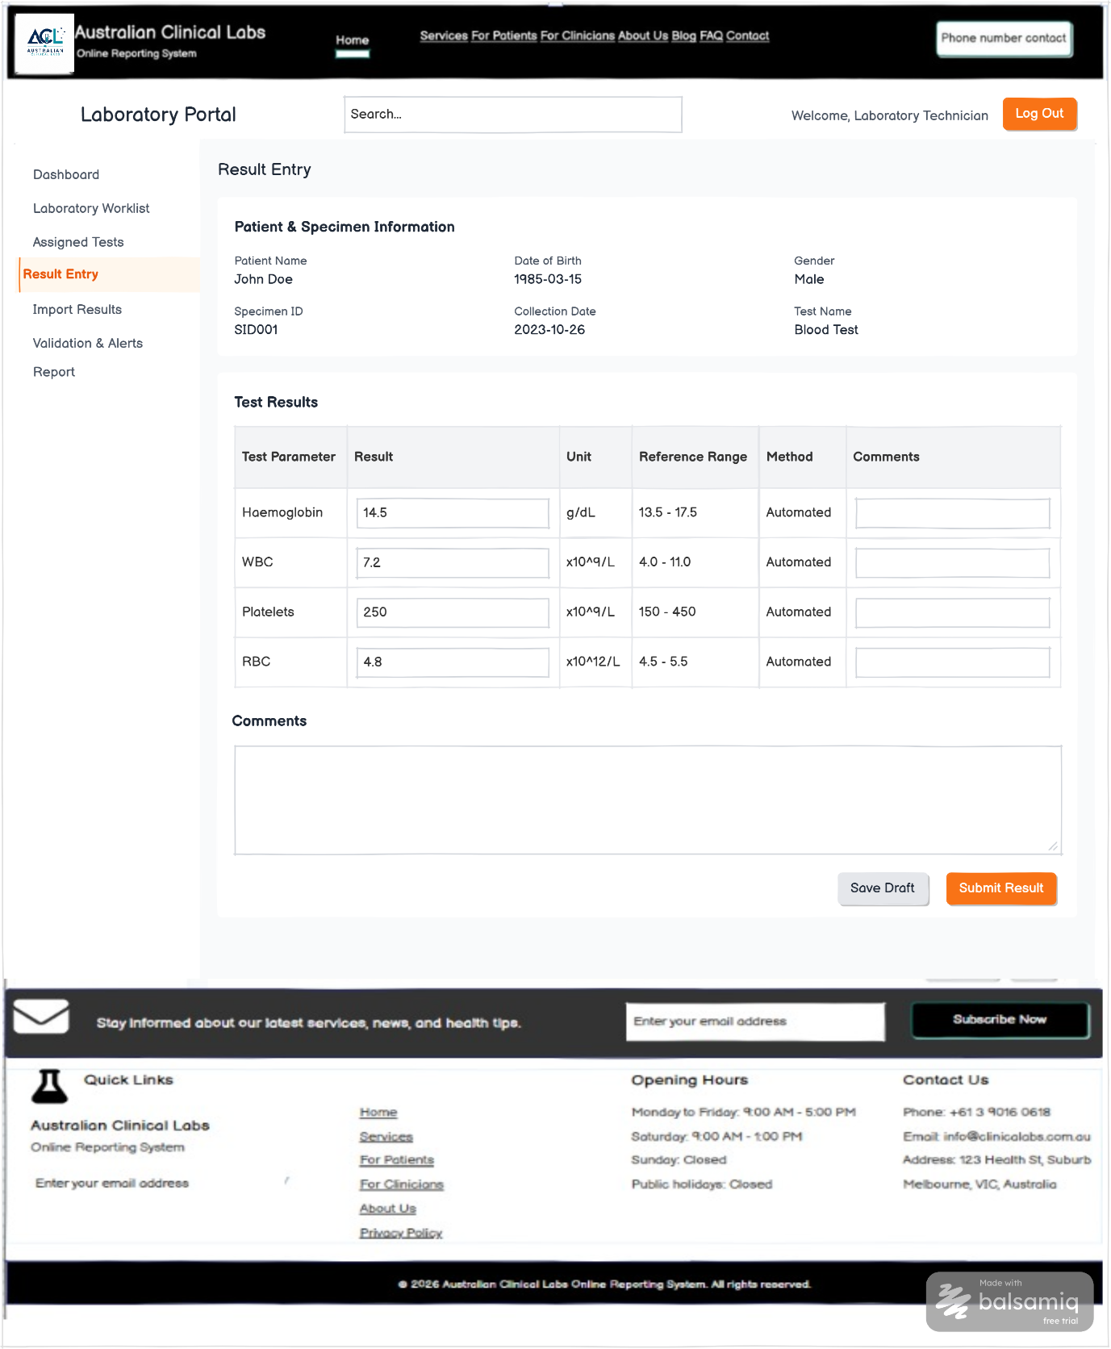
- Assigned Tests Screen (FR26)
The Assigned Tests screen displays laboratory tests allocated to the logged-in laboratory technician or scientist. It allows users to review assigned specimens, monitor priorities and due times, and open individual tests for result processing. This interface supports efficient task management and workload distribution within the laboratory.

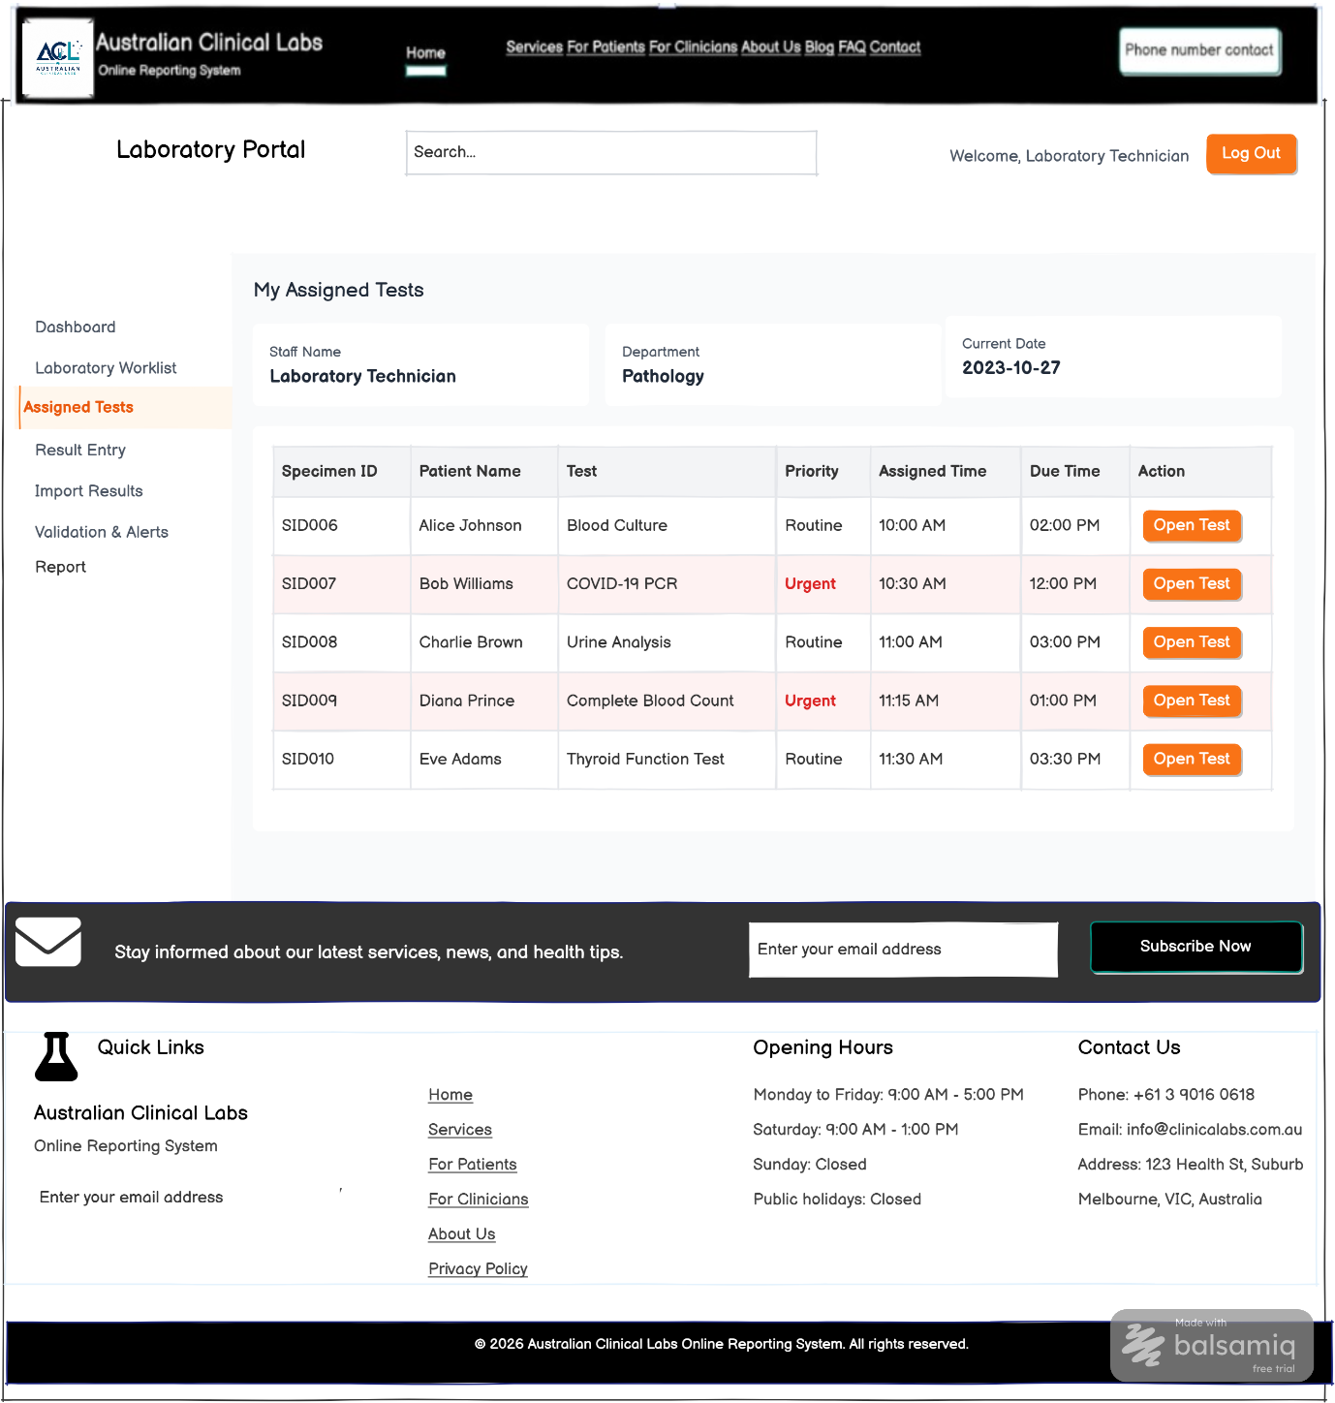
- Validation & Alerts Screen (FR29–FR30)
The Validation & Alerts screen assists laboratory staff in reviewing test results before submission. The system validates entered data against predefined rules and automatically highlights abnormal values that fall outside the reference range. Users can review flagged results, add notes if required, and approve validated results for the next stage of the reporting process.

